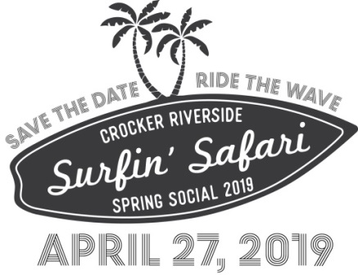

Sponsorship Opportunities

The Maverick: $1,000(2 available) SOLD OUT
– Naming rights for the event and inclusion of logo on all event materials
– 2.5’ x 10′ banner at event
– Logo featured on event banner and on website for three months & on event invitations
– Logo on Table top signs
– Featured in Facebook pages and website advertising for event
– Listing on event Thank You banner
– 4 tickets to event

Pipeline Master: $750 (Two available) SOLD OUT
– Naming rights for Family Party Sign-up & Teacher Party sign-up area
– 2.5’ x 6’ banner at event
– Logo on event banner and on website for three months
– Logo on Table top signs
– Featured in Facebook pages and website advertising for event
– Listing on event Thank You banner
– 2 tickets to event

Quicksilver: $500 (One available) SOLD OUT
– Naming rights for Wall of Wine
– 2.5’ x 4’ banner at event
– Featured in Facebook pages and website advertising for event
– Logo on event banner and on website for three months
– Logo on table top signs
– Listing on event Thank You banner
Hang Ten: $250 (unlimited)
– Featured in Facebook pages and website advertising for event
– Logo on event banner
– Logo on table top signs
– Name listed on website for three months
– Listing on event Thank You banner
Shaka: $100 (unlimited)
– Featured in Facebook pages and website advertising for event
– Logo on event banner
– Listing on event Thank You banner
– Name listed on website for three months

Hodad: $50 (unlimited)
– Featured in Facebook pages and website advertising for event
– Logo on event banner
– Listing on event Thank You banner

